To change back the PWM conversion to 10

1. Navigate to the project:

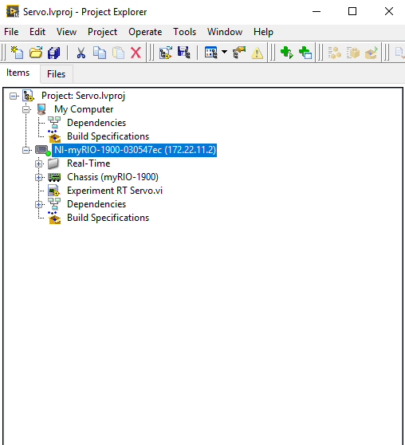

1. Expand the Realtime folder and the SubVIs folder:

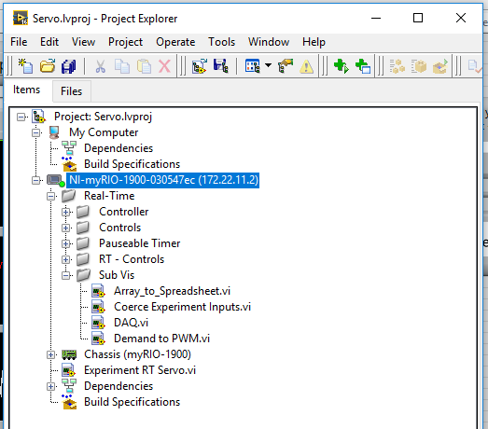

1. Double click on ‘Demand to PWM.vi’ to open it:

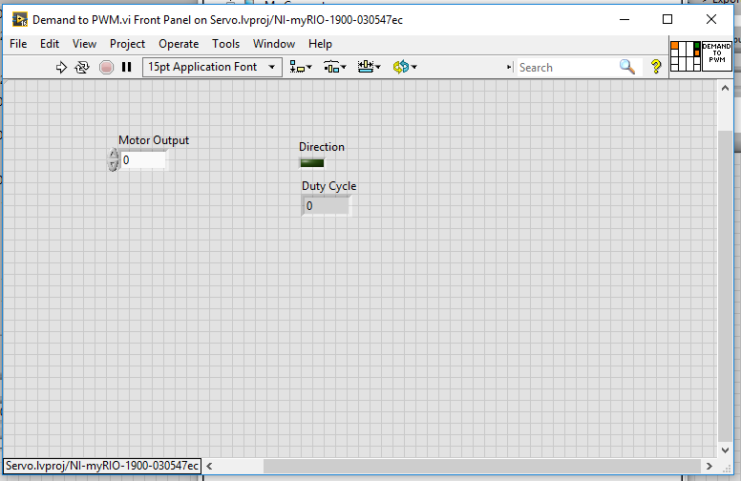

1. Open the Block Diagram:

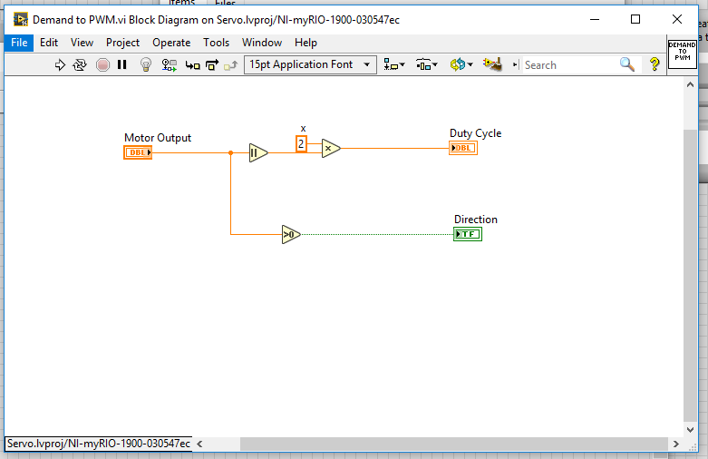

1. Double click on the constant and type in the desired value (10):

